

Heat Transfer: Automotive heat exchangers (car radiators)

TEAM 9

**Program: Mechatronics**

### Course Code: MEP212

### Course Name: Heat Transfer

### Examination Committee

## Dr. Yasser Saad

## Dr. Mostafa Abdelkhalek

#### Ain Shams University Faculty of Engineering

1 |

P a g e

##### Table of Contents

Heat Exchanger

Types of heat exchanger

Heat Exchanger Tube failure

## Radiator in a Car

## Calculation of Heat Transfer Rate and Outlet Temperature

Radiator Thermal shock (situation control)

Flow Chart

# 

# Heat exchanger

* A **heat exchanger** is a system used to transfer heat between a source and a [working fluid](https://en.wikipedia.org/wiki/Working_fluid). Heat exchangers are used in both cooling and heating processes. The fluids may be separated by a solid wall to prevent mixing, or they may be in direct contact. They are widely used in [space heating](https://en.wikipedia.org/wiki/Space_heating), [refrigeration](https://en.wikipedia.org/wiki/Refrigeration), [air conditioning](https://en.wikipedia.org/wiki/Air_conditioning), [power stations](https://en.wikipedia.org/wiki/Power_station), [chemical plants](https://en.wikipedia.org/wiki/Chemical_plant), [petrochemical plants](https://en.wikipedia.org/wiki/Petrochemical), [petroleum refineries](https://en.wikipedia.org/wiki/Oil_refinery), [natural-gas processing](https://en.wikipedia.org/wiki/Natural-gas_processing), and [sewage treatment](https://en.wikipedia.org/wiki/Sewage_treatment). The classic example of a heat exchanger is found in an [internal combustion engine](https://en.wikipedia.org/wiki/Internal_combustion_engine) in which a circulating fluid known as [engine coolant](https://en.wikipedia.org/wiki/Engine_coolant) flows through [radiator](https://en.wikipedia.org/wiki/Radiator) coils and [air](https://en.wikipedia.org/wiki/Air) flows past the coils, which cools the coolant and heats the incoming [air](https://en.wikipedia.org/wiki/Air). Another example is the [heat sink](https://en.wikipedia.org/wiki/Heat_sink), which is a passive heat exchanger that transfers the heat generated by an electronic or a mechanical device to a fluid medium, often air or a liquid coolant.

# Types of heat exchanger

* [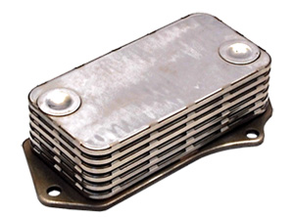](http://www.thermex.co.uk/product/brazed-plate-heat-exchangers)[**Shell and Tube**](http://www.thermex.co.uk/products/shell-and-tube-heat-exchangers)**:** Shell and Tube Heat Exchangers consist of a large number of small tubes which are located within a cylindrical shell. The tubes are positioned into the cylinder using a tube bundle or "tube stack" which can either have fixed tube plates (permanently fixed to the body) or, in the case of Thermex Heat Exchangers a floating tube stack which allows the tube bundle to expand and contract with varying heat conditions as well as allowing the tube bundle to be easily removed for servicing and maintenance.
* [**Plate Type**](http://www.thermex.co.uk/products/brazed-plate-heat-exchangers)**:** Plate Heat Exchangers operate in very much the same way as a shell and tube heat exchanger, using a series of stacked plates rather than tubes. Plate heat exchangers are usually brazed or gasketed depending on the application and fluids being used. Their compact stainless steel construction makes them an ideal choice for use with refrigerants or in food and beverage processing.
* [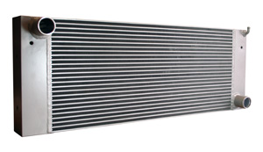](http://www.thermex.co.uk/product/air-cooled-heat-exchangers)[**Air Cooled**](http://www.thermex.co.uk/products/air-cooled-heat-exchangers)**:** Air Cooled Heat Exchangers are commonly used in vehicles or other mobile applications where no permanent cool water source is available. Thermex designs and supplies

combination cooling packs (or combi-coolers) which combine an engine jacket water cooler, oil cooler and charge air cooler

* into a single unit reducing space requirements and improving efficiency. Cool air is provided either

by a fan or by air flow caused by the movement of the vehicle.

# Heat Exchanger Tube failure

### Tube Corrosion

* The biggest threat to shell and tube heat exchangers that use carbon steel tubes is oxidation

(corrosion) of the heat transfer surface of its tubes.

The reaction between oxygen (O2) and iron (Fe2, Fe3) is the most commonly observed form of corrosion. This reaction yields a building layer of iron oxide (Fe2O3) on carbon steel tubes which results in decreasing thermal permeation and eventually the deterioration of the tubes. This problem

is difficult to combat and is often only detected when tubes become so corroded their thermal performance levels decrease, the fluid flow is significantly reduced, or the tubes are perforated and leak.

### Tube Erosion

* Erosion of tubes is the physical wearing of the metal by fluids. Fluids with high levels of total

dissolved solids – such as silica, silt or sea water containing salt, sand and marine life – catalyze

* the erosion of tubes both internally and at the leading edges of the inlet tubes.

Although all tubes are subject to erosion over time, the weakest points for tubes are generally the

U bend (if any) and the leading edge of the inlet tubes.

#### U-bend Erosion

* Tube-side fluid velocity in excess of manufacturers’ recommendations can lead to erosion damage along the internal face of the returning outer bend of the U-bend. The change in direction of flow at this point introduces resistance to its flow causing the force of the fluid, and any particulates in it,

to concentrate against the far wall of the tube, constantly eroding the tube at this point.

#### Inlet Tube-end Erosion

* Significant erosion of the tubes can also be found at the leading ends of the inlet tubes, where the tubes are connected through the tube sheets and face the full force of the incoming fluid. At this

point the division of fluid flow from a single stream into many smaller streams results in turbulence and extremely high localized velocities.

### Steam or Water Hammer

* Steam or water hammer is a powerful force and can cause the rupture or collapse of either the shell
* or the tubes of a heat exchanger. Hammer generally occurs where there has been a surge in pressure commonly caused by a sudden interruption in cooling water flow, the rapid vaporization of stagnant water or pump malfunction. The phenomenon can be observed in [feed-water heaters](http://fluiddynamics.com.au/feedwater-heaters-cost-effective-environmentally-friendly-solutions/) where high
* steam pressures increase the chances of hammer.

Hammer can often be heard, but only rarely will it damage the shell. Tubes, being weaker than the shell, are the more likely victims of hammer, however damage to tubes will only be detected on internal inspection or when leaks become apparent.

### 

### Thermal Fatigue

* Heat exchanger tubes are vulnerable to tears and cracks due to accumulated stresses related to

constant thermal cycling or high temperature differentials. Thermal fatigue occurs when extreme temperature differences between the shell and tubes result in tube flexing.

* Thermal fatigue may cause the tubes to warp, producing stress loads that exceed the material’s

tensile strength and will eventually rupture the tube.

* Another result of high temperature differentials is the physical thermal expansion and contraction of tubes along their length, which may eventually compromise the integrity of a tube’s connection to the tube sheet, causing leaks.

The threat of thermal fatigue is almost impossible to diagnose until a failure has occurred.

# Radiator in a Car

* The radiator helps keep your vehicle cool, but how exactly does it achieve this goal?

The engine in a vehicle burns fuel and creates energy, which generates heat. Venting this heat away from engine parts is important to prevent damage.

Radiators work to eliminate heat from the engine. The process begins when the thermostat in the

front of the engine detects excess heat. Then coolant and water get released from the radiator and

sent through the engine to absorb this heat.

Once the liquid picks up excess heat, it is sent back to the radiator, which works to blow air across it and cool it down, exchanging the heat with the air outside the vehicle.

The radiator utilizes thin metal fins during the process, which are effective at allowing heat to

quickly escape to the air outside the car. These fins are often working alongside the fan that’s

blowing air across the radiator.

Long story short, the answer to “What’s a radiator in a car?” is simple — It is a heat exchange that cools fluid, which cools down the engine.

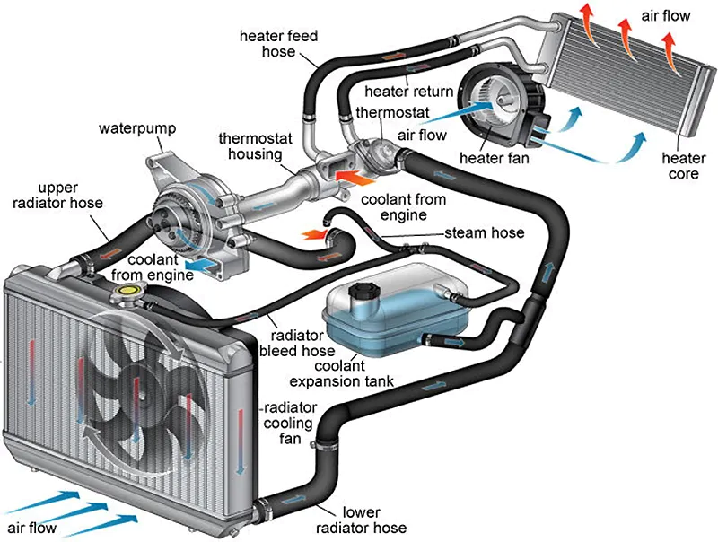

## Signs of a Failing Radiator

* **Leaking coolant:**

Cracks or leaks in the radiator will cause coolant to appear on the ground underneath your vehicle. This can happen when your vehicle is parked or when you’re driving. If you notice this or low

coolant levels, you might have a crack in your radiator.

* **Discolored coolant or sludge:**

Coolant is usually a thin consistency and colored green or yellow. Rust and debris from a failing radiator might cause contamination in the fluid that can turn it a dark or rusty color. It also might become thicker and create sludge, which can prevent it from cooling the engine.

* **Overheating**

 A vehicle consistently overheating could be a radiator issue, since the radiator is the way engine heat is removed.

* **Bent or damaged fins**

 Airflow can get blocked to the radiator if the fins on it get bent or damaged. This can be caused by gravel hitting them while driving or if too much water pressure is used while cleaning them.

# Calculation of Heat Transfer Rate and Outlet Temperature

Table 1. Specifications of the Radiator

|  |  |  |  |  |  |
| --- | --- | --- | --- | --- | --- |
| **No.** | **Descriptions** | **Symbols** |  | |  |
| **1** | Radiator Length | Lr |  | |  |
| **2** | Radiator Height | Hr |  |  |  |
| **3** | Radiator Width | Wr |  |  |  |
| **4** | Tube Length | Lt |  |  |  |
| **5** | Tube Height | Ht |  |  |  |
| **6** | Tube Width | Wt |  |  |  |
| **7** | Fin Length | Lf |  |  |  |
| **8** | Fin Distance | Df |  |  |  |
| **9** | Fin Width | Wf |  |  |  |

**10** Number of Tubes Nt

* 1. Assumptions

The heat transfer analysis of automotive radiator is done by considering the following assumptions.

1. The cooling system operates under steady-state conditions that are constant coolant flow-rate and fluid temperatures at both inlets.
2. Air velocity must be changed for constant the air flow rate with the changing of the radiator height.
3. There are no phase changes in the fluid streams flowing through the radiator.
4. Pure water is used as a coolant.
5. The thermal conductivity of the radiator material is constant.
6. Heat conduction in the wall is negligible.

Calculation of Relevant Heat Transfer Areas

The coolant and air surface areas can be calculated from equations (1) and (4), Coolant surface area,

Ac = Nt ×[2(Lt × Hr) + 2(Wt × Hr)] (1)

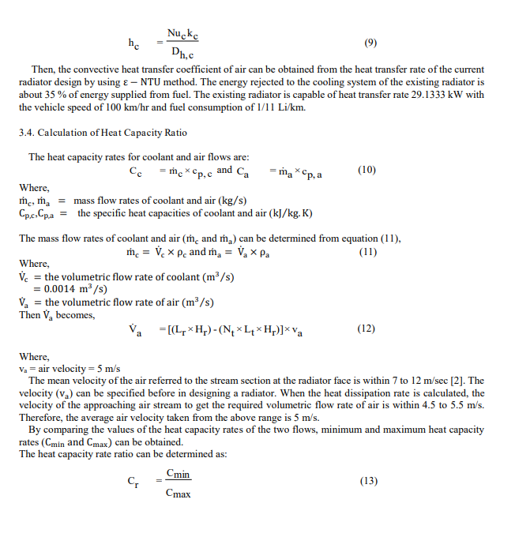

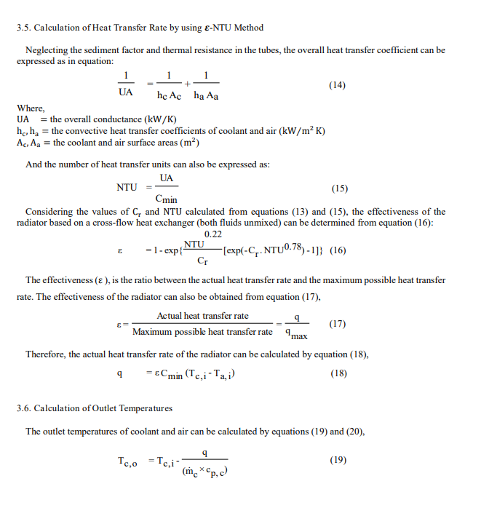

# 

# Radiator Thermal shock (situation control)

### What is thermal shock?

* Let’s explore the idea of thermal shock on a basic level. Engines and engine bay components are tested and designed to work under a variety of temperature conditions. Even so, they can become stressed when exposed to extreme temperatures.

Exposure to extreme temperatures, particularly at a high rate of change can be damaging to components like your radiator. This process is known as temperature cycling, where the system cycles between 2 extremes rapidly.

This can sometimes happen in a radiator as hot coolant travels through the radiator tubes. The temperature difference forces the metal to flex and expand – which is known as thermal expansion – and contract once the heat decreases.

If it happens frequently, particularly in a specific area, it can begin to fatigue the material and lead to component failure. This is known as thermal shock. This is commonly found where the tube meets the header plate, resulting in cracks, brittleness or deterioration of the metal.

### Thermal Shock Resistance

* [Thermal shock](https://www.sciencedirect.com/topics/materials-science/thermal-shock) can be defined as serious cracking in components subject to rapid changes in temperature. Refractories often [microcrack](https://www.sciencedirect.com/topics/engineering/microcracks) but if this does not lead to mechanical failure of the component it is not regarded as a problem. Failure from [thermal shock](https://www.sciencedirect.com/topics/materials-science/thermal-shock) is caused by incompatible changes in dimension and failure occurs in regions where the strain locally exceeds the tensile failure strain.
* Mathematical expressions for the thermally induced stress in materials of various shapes were summarized by Hasselman (1985). For shapes such as a constrained flat plate the peak stress typically occurring at the surface on cooling is
* where σth=thermal stress, E=Young's modulus, α=coefficient of thermal expansion, and ν=Poisson's ratio.
* ΔT is affected by the thermal conductivity (k) of the material. This equation indicates that σσth increases as E, α, and ΔT increase. For a given material E and α cannot be varied but we can alter ΔT. From a materials point of view, ΔT can be decreased by increasing the k of the material. The terms in this equation can be rearranged to give a thermal shock resistance parameter, R

The R parameter estimates the ΔT (in °C) that the material can withstand prior to formation of thermal shock cracks.

**How to avoid and control thermal shock in radiator?**

* By knowing the properties of radiator material. we can measure the max difference of temperature (thermal shock resistance parameter) and by using thermocouple or any temperature sensors(Tin & Tout) we can avoid thermal shock

# Flow Chart

